Skillz Design Document  
**Evolution - Match3**

short line

|  |  |  |
| --- | --- | --- |
| Date | Author | Change Log |
| Feb.22.2021 | Ignac Balogh | Created Concept |

# Objective

The purpose of this document is to summarize the design of Evolution - Match3 (working title), a new match-three game that will be built by Human Soft. This game was designed from the ground up for cash competition on the Skillz mobile eSports platform. This document will be updated as needed if any changes are made to the plan.

Where appropriate, additional information will be provided to guide the implementation of the game based on the agreed-upon plan. This guidance is based on design expertise that we have observed working successfully on previous games, and it is meant to provide insight into key issues rather than a formal prescription.

# Design Overview

### **Core Gameplay**

### Evolution - Match3 is a timed match-three based game in which the player swaps adjacent animals (or plants) to form matching lines of three or more, which causes the animals to disappear from the grid. When this happens, the game objects fall downward to fill in any gaps, and a new animal comes in from the top of the screen. When matches are made at the bottom line scene scrolls down to reveal new world elements as treasures, and RNA sample. Bunch of matches, or RNA samples will trigger an evolution of animals, that will give new abilities to animals that could be achieved by selectable boost items and some of them will be applied automatically. The system is complex (not fully explained in this doc), but easy to learn as all elements of it have been represented on the screen and reflect the meaning of evolution.

### Depending on the level (meaning tutorial level or bet / game level) a player starts on a different stage (4 will be included) where different flora or fauna is presented. Making the learning curve longer, and require more skills on higher levels.

Treasures are an extra elements of the game, that could be earned when player has dug down on the world (scroll scene by digging the bottom line), to give an extra strategy to skilled players.

The game ends when the timer runs out.

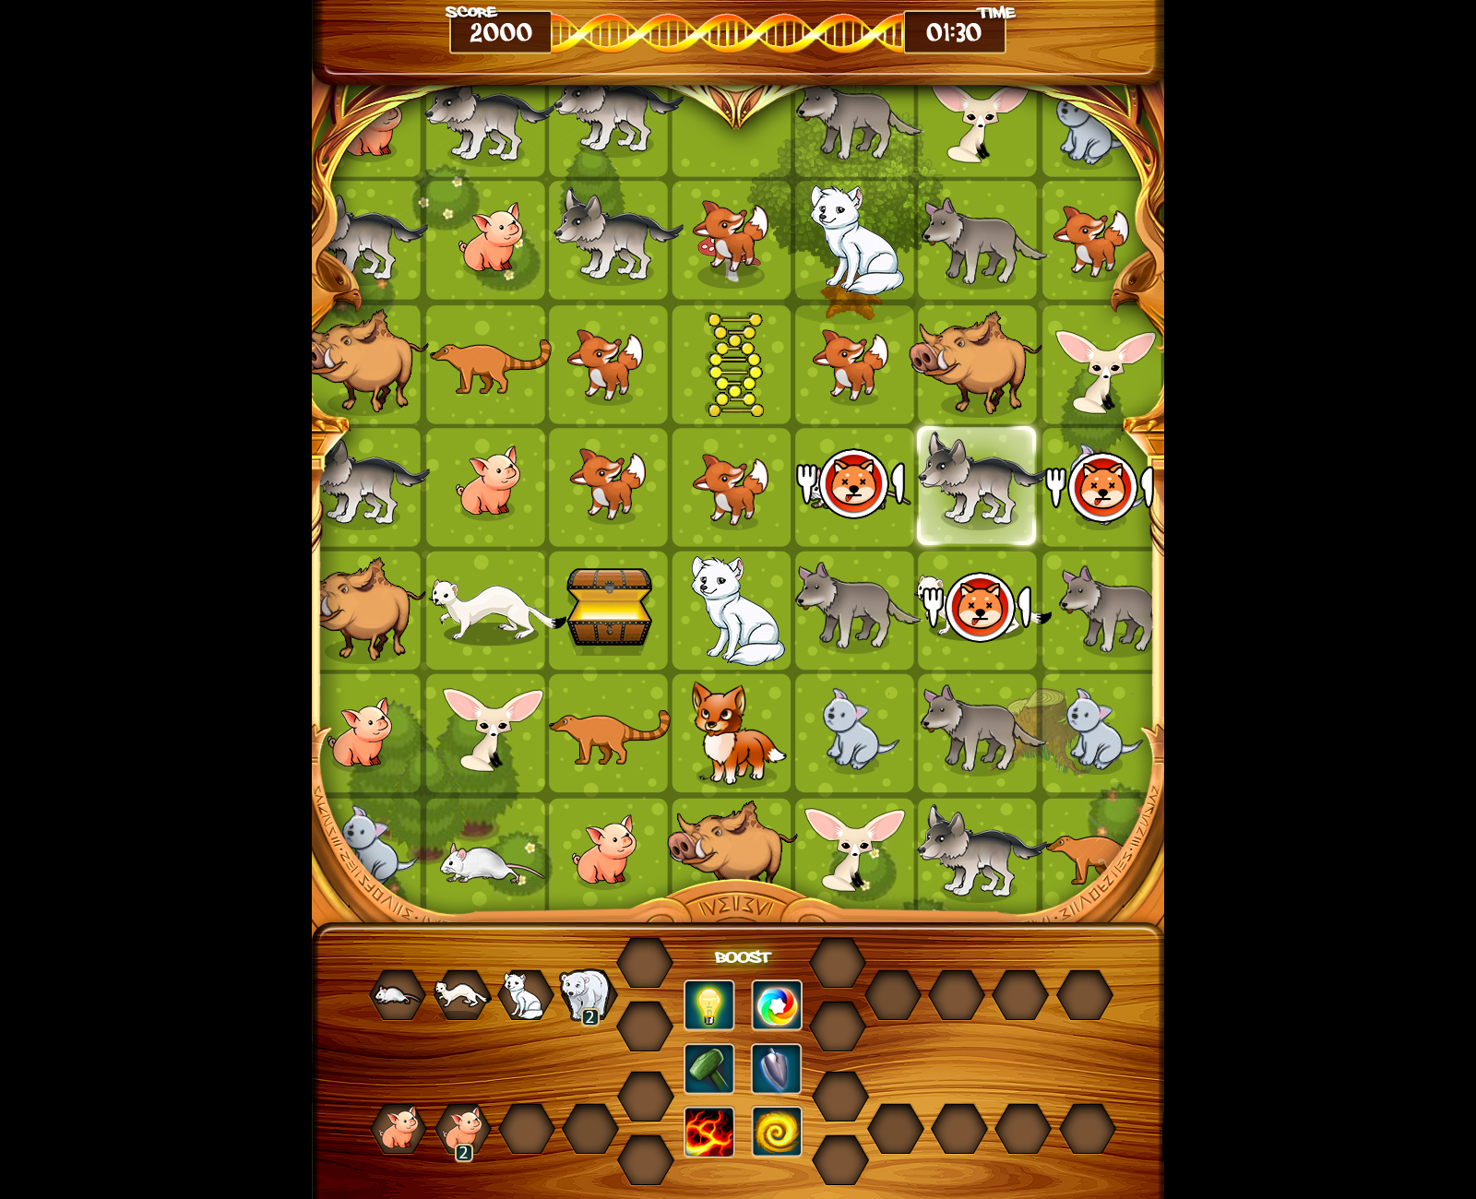

**Game Board Setup**

Game takes place on a tall 8 x 8 grid with a RNA and evolution progress meter. At the beginning of the game, the grid will be populated with 4 types of animals.

The initial game board setup will need to be run through an algorithm to ensure that no matches exist at the beginning of the game.

**Evaluating Matched Game Objects**

There are several different types of matches that players can create by swapping items around. All matches must be in a line. (If the player creates a T or L shape, it would be evaluated as two intersecting lines.) Here is how each such match should be handled:

● Lining up three matching animals​ -- The animals vanish in a puff of smoke. The meter fills by three. Game objects fall down from above to fill the void, and new game objects fall in through the top of the board.

● Lining up four matching animals ​--​ ​A “blast wave” explodes out from both ends of the line, causing all animals in the row or column (depending on which way the animals were lined up) to vanish in a puff of smoke. The meter fills based on the number of animals destroyed. RNA samples, and treasure chests are NOT destroyed by the blast wave.

● Lining up five matching animals​ -- A 5x5 vast wave explodes out from the line causing all affected animals to be destroyed. The meter fills based on the number of animals destroyed. RNA samples, and treasure chests are NOT destroyed by the blast wave.

**Competitive Format(s)**

Matches will take place in an asynchronous tournament format in which each player plays individually to receive a score. Once all players in a match have completed their games (which need not take place at the same time) the match will resolve with the highest scoring player declared as the winner.

Each match will consist of a single continuous game limited by a game timer. The game ends when the timer runs out or the player quits the game from the pause menu.

### **Scoring / Win Conditions**

### The player who earns the most points will win each match. Below is a list of all the game actions that award points. The actual point values should be parameterized. (Refer to the “Game Parameters” section for further details.) The score values below are just examples.

### ● Matching animals ​ -- 10 points per animal

### ● Evolution achieved​ -- 200

### ● Reach second branch of evolution line -- 1000 points (as there is a fork in the line)

### ● Treasure​ – 1000 points

### **Tutorial / First Time User Experience**

### When a user plays the game for the first time, a brief tutorial will be presented that covers the

### most important elements of the game:

### ● Swap items to create lines of three or more matching animals

### ○ Tap and drag to swap

### ○ Only moves that make a valid match are allowed

### ● Match more than three items to activate an explosive effect

### ○ Matching four in a row creates an explosion that removes the entire row or

### column

### ○ Matching five in a row creates a 5x5 explosion centered on the line

### ○ Explosions do not destroy RNA samples, and treasure chests.

### ● Evolution

### ○ Achieve next level.

### ○ Use RNA samples to Achieve secondary line.

### ● Treasure

### ○ Dig bottom line to get it.

### ● Boost items

### ○ Expose all of them

### ● The game ends when the timer is up

### **Fairness Considerations**

In order to ensure that players are competing on a level playing field, each player in a match will  
receive the exact same starting board configuration. Additionally, each column will be generated  
by a seeded RNG (all seeded using Skillz Random) so that the same sequence of game pieces  
will fall into each column as it is cleared. (Exception: When a animals is generated, it gets inserted into the column where the player ended his or her swap, delaying the animals that would have fallen there.)

**Main Game UI**

The game should be locked in “portrait” orientation. The user interface during gameplay will contain the following elements:

● Score (Top Right) ​- The player’s current score, with commas for values over 999.

● Time Remaining (Top Left) ​- The time remaining in the match in M:SS format.

○ The timer counts downward to zero. When it reaches 15 seconds, it should turn red and pulse once per second.

● Game Board (Center Right)​ - The 8 x 8 grid filled with animals. The background of the game board should have a low-contrast world of an relevant epoch of surface of earth.

● RNA sample meter

● Evolution lines per animals (4)

● Boost items (5 types)

● Pause Button (Bottom Left) ​- This button should have a pause symbol on it (two horizontal lines). Tapping it should do the following:

○ Hide the gameboard

○ Provide a very brief overview of how to play

○ Offer a menu of these options:

■ Resume Game

■ Sound Effects On/Off

■ Music On/Off (if any)

■ Quit Match - This should submit the player’s current score.

**Game Controls**

The controls for this game are very simple. The player touches and drags a piece to swap it with

an adjacent piece. Here are some additional details of how the animations will work:

● Once the player has dragged a piece a few pixels toward another piece, the game

pieces will immediately swap.

● If the swap did not result in a match being made, the game pieces will immediately swap

back to where they began.

● If a player keeps his/her finger on the screen after a swap, the touch will be ignored until

the player lifts the finger and begins a new move.

● Dragging a game piece toward the edge of the board has no effect.

● After a move is made, the game model should update (behind the scenes) even if

animations are still on-screen. Additional moves can be made based on the new

positions of game pieces, although the new moves might not animate until the previous

animations complete.

● Multi-touch is not supported on the game board. Touching the screen in multiple places

at once within the grid will interfere with the ability to make swapping gestures.

Game Parameters

|  |  |  |
| --- | --- | --- |
| A comprehensive lists of parameters we recommend adding to configure match rules and award points for scoring are as follows. **Format Rules** | | |
| **Parameter** | **Values** | **Notes** |
| match_timer | **180** | Match time limit in seconds |
| level | **1..4** | level (different epoch of evolution) |
| **Scoring** | | |
| **Parameter** | **Suggested Values** | **Notes** |
| score_animal | **10** | The score value for each animal removed |
| score_RNA_sample | **100** | collect RNA sample |
| score_treasure | **500** | Collect treasure earned |
| evolution_levels | **100** | Multiplied by evolved level of tiles.. |
| evolution_branch | **500** | Achieve secondary branch. |

## 

## APPENDIX

## Screenflow Summary

|  |  |  |  |
| --- | --- | --- | --- |
| **Load App** | **Skillz SDK** | **Gameplay** | **Skillz SDK** |
| 1b Title Screen  1a Tutorial | 2 Welcome Back  3 Tournament Select  4a Async Match-making | 5 Pre-game Level story  6a-6c Play Match  6d Pause Screen  7 Results Screen | 8 Match Results  9 Video Replay |
|  | | | |

## 

## Screen Flow Descriptions

|  |  |
| --- | --- |
| **Screens & High-Level Instruction** | **Example Mocks** |
| **1b On First App Open the game immediately funnels players through a Tutorial experience getting them to gameplay immediately.**  1. This will circumvent the Main Menu and SDK tournament user flow steps 1b **-** 4 so that the player can learn to play through tutorial.    1. When exiting this first attempt, the player will be returned back to the main screen 1b. 2. On subsequent loads, the player should start at 1b. |  |

|  |  |
| --- | --- |
| **1a Tutorial**  1. This flow behaves differently on the first load    1. On first load exiting the tutorial should circumvent the Main Menu and SDK tournament user flow steps 1b **-** 4 so that the player can learn to play through tutorial.    2. When exiting this the tutorial on later attempts, the player will be returned back to the Welcome Back screen 2.    3. Rarely a request will be made to insert the Tutorial as a Pause Menu option. | (Mock of tutorial gameplay) |

|  |  |
| --- | --- |
| **1b After FTUE, Player Loads the App to the Start Screen and proceeds to a Main Menu.**  1. These are client screens controlled by the game 2. The Main Menu is where to put settings or alternative modes like “Tutorial” which will allow players to replay them. 3. Tapping “Play” will load to the Skillz SDK.    1. We have found that creating stronger focus on the Play button over other screen elements improves Install to 1z and D1 metrics and suggest making the callout extremely obvious. 4. Tapping Play button proceeds to screen  **2.** | (Mock of title screen) |

|  |  |
| --- | --- |
| **2 Game loads to Skillz SDK, player is shown the “Welcome Back” screen**  1. Shows results of completed games, rankings in tournaments, pending games, etc. 2. New players are placed into an account creation and Skillz Onboarding Tutorial 3. Tapping the GAMES tab button moves to screen 3 |  |

|  |  |
| --- | --- |
| **3 The Games list displays different tournament types, with varied stakes**  1. This includes: virtual currency (“z”) matches 2. Cash async matches 3. Live events 4. Bracket or other style multiplayer tournaments 5. Each tournament has a name, an entry fee and potential rules or tuning changes. 6. Skillz recommends a specific ruleset for all asynchronous tournaments. 7. Synchronous tournaments will be addressed separately at a later time. |  |

|  |  |
| --- | --- |
| **4 Player chooses a tournament and is matched with another player**  1. Skillz provides an ELO-based “skillz difficulty” rating to determine AI difficulty. Skillz suggests assigning these difficulty levels appropriate names to create a sense of progression and to support the expectation of increasing AI difficulty as a player ascends. The use of “sample tournament” is an example and should be replaced by the best game equivalent. 2. Skillz Random will be used to define the AI opponent list, ensuring players get the same experience. |  |

|  |  |
| --- | --- |
| **5** SDK passes the player back to clientgameplay, beginning with Pre-Gamechoreography to ensure players are readywhen tournament begins.  1. Pre-game choreography should display level, and its story as different time range of evolution. 2. For games with tunable or selectable characters, we recommend using this opportunity to allow players to configure the game for the match and ready up. 3. We recommend displaying a countdown to punctuate when the match begins for the player. Examples:i. Ready, Set, GO! ii. 3, 2, 1, GO! | (Mock of pre-game screen) |

|  |  |
| --- | --- |
| **6a Fight begins; Player fights first AI opponent**  1. The match begins with a three-minute (180s) overall timer. This can be set as a game parameter so Skillz can help experiment with different timer lengths. 2. The UI can display a configurable number of victory icons in Async Survival mode.    1. Victory icons appear only after a fighter has been KOed    2. No more than (8) victory icons appear in HUD simultaneously.    3. If the player defeats more than (8) fighters, the victory icons area becomes a double digit counter showing one victory icon with a number next to it. 3. There is an onscreen pause button 4. We recommend optimizing for skill scoring caps by visualizing attack damage in the health meter similarly to chip damage in other fighting games:    1. When taking a hit the health meter of the fighter struck decreases as normal. The delta between the amount of health before the hit and after the hit appears in a different color, and then quickly disappears (suggest 2-3 secs) to reinforce the strength of each attack. | (Mock screen of gameplay) |

|  |  |
| --- | --- |
| **6b If player wins against 1st opponent, player fights another AI opponent**  1. After defeating the first fighter, the player gets a short breather, then the second fighter arrives. 2. Both, Health and Time is carried over between all fights. If the player ever dies OR the time runs out, the match is over.     1. Timer should be configurable as a Skillz parameter. 3. As the game is nearing its time limit, give the player a visual and audio cue. | (Mock screen of exciting score during gameplay) |

|  |  |
| --- | --- |
| **6c Player fights additional AI opponents**  1. Score is determined throughout the match. Defeating a fighter should provide a large component of the score in any fight. 2. Score is displayed as it tallies in the top right corner. 3. As the game is nearing its time limit, give the player a visual and audio cue. | (Mock screen of exciting score during gameplay) |

|  |  |
| --- | --- |
| **6d Pause Screen is accessible during gameplay.**  1. Elements which should be included on the Pause Menus Include     1. Music and SFX Toggle Controls.    2. Score, which is determined throughout the match. If at any time the player pause the match, the sum of their current points should be totaled for them to make an informed decision about whether they want to submit their score early.    3. Exit and Return Buttons       1. Exiting should display a confirm to prevent accidental, early exits. | (Mock screen of exciting score during gameplay) |

|  |  |
| --- | --- |
| **7 Game ends with score summary**  1. The match can end when:    1. The timer is 0 2. The score screen displays a breakdown so the player can see how the overall Score is calculated.     1. Score is submitted after the player presses “Submit Score” or automatically after 10 seconds.       1. An onscreen meter drains to indicate time remaining until auto-submit happens.    2. Recommended Score breakdown:   Animals gathered: ​ ​ [Points Earned]  Evolutions achieved: ​[Points Earned]  Secondary evolutions reached: ​[Points Earned]  Treasures found: ​ [Points Earned] Final Score: [Total Points Earned] | (Mock of pre-game screen) |

|  |  |
| --- | --- |
| **9 Client gameplay submits score back to skillz SDK, displaying match end screen**  1. If the opponent has not finished or been matched-up yet, there are variants of this screen. 2. Tapping next goes back to screen #2 and displays match results. |  |

|  |  |
| --- | --- |
| **10 Player can watch a replay (of cash games) to compare performance to the opponent.**  1. The replays can inform the player of how the opponent played and give a good sense of the meta game. Skillz will investigate starting replays at the last frame so it will be easy to get a side-by-side view of both players score breakdown. |  |

### Pause Button

Because players are usually playing for real money in our games, the outcome of a single match is more important to them than might be expected for most mobile games. But because they are playing on a mobile device, often while in transit or being interrupted, they often strongly desire to pause the game. The best practice is to include a pause button that pauses the game and hides any information that the player could use to gain an advantage by pausing frequently. In addition, we will be limiting the number of times players can pause in a single game to help safeguard from cheating.

### Controls for Muting Game Audio

Players often use their devices for multiple functionalities at once - especially, listening to music/audio from a background app while playing a game. Give people options to mute their SFX and Music  
Sound effects will be present for the following game actions:  
● Game start countdown  
● Matching three animals (animals disappear in a puff)● Matching four animals (the entire row/column explodes)● Matching five animals (a blast wave destroys a 5x5 area)● Matching three coins● Matching four coins (double coin bonus)● Matching five coins (triple coin bonus)● Attempting an invalid move (pieces swap back to their original position)● Timer running out (15 seconds left warning)● Out of time● Game end fanfare● Scoring roll-up● UI button tapsMusic may also be included for the game start screen and/or during gameplay (TBD)

short dash